**INTRODUCTION TO PYTHON**

**LAB SHEET-6**

**NAME : Harishankar Binu Nair**

**Roll no : AM.EN.U4AIE22023**

1. Create the tables as per the instructions given and insert suitable data.

Table DOCTOR:

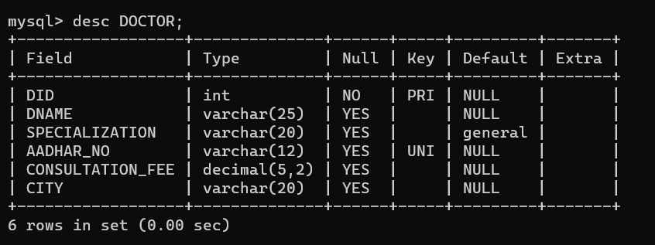

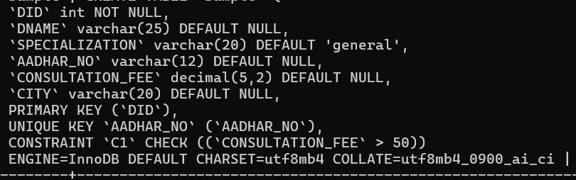

Inserting data to DOCTOR:

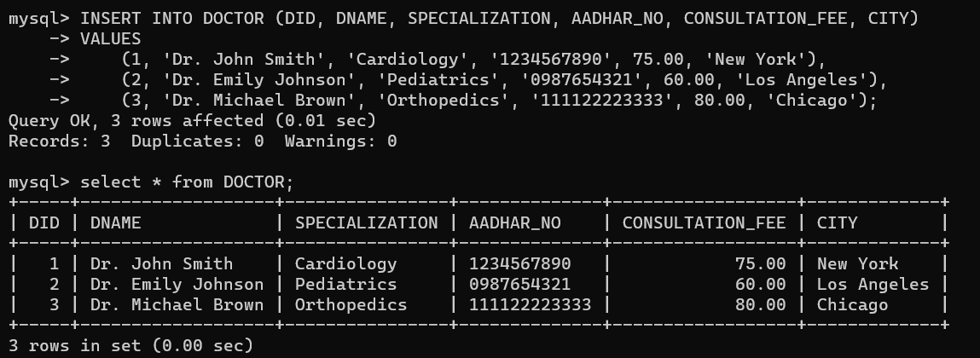

Table PATIENT

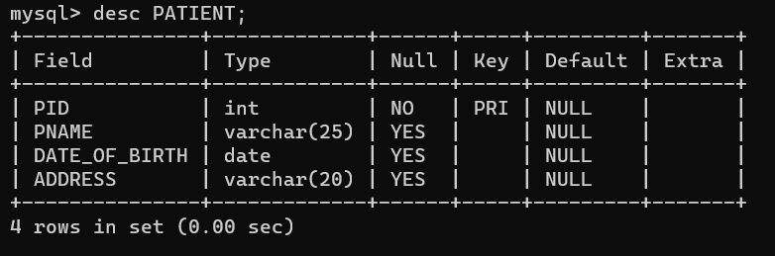

Inserting data into PATIENT

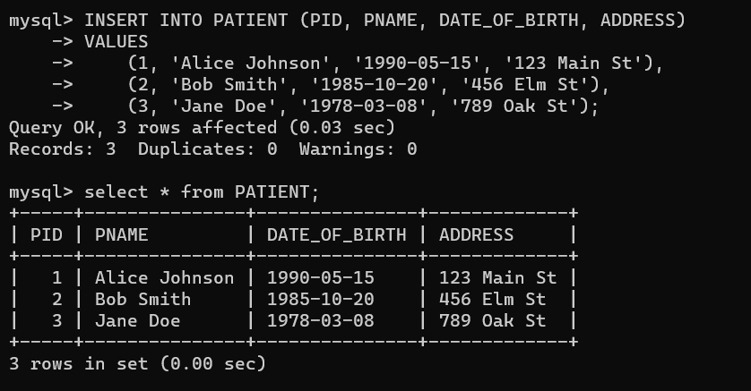

1. Add a column called SPECIAL_FEE with data type NUMERIC(5,2) to DOCTOR table

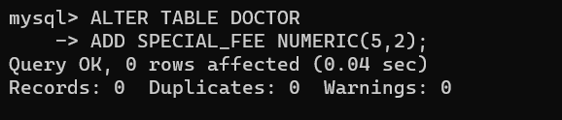

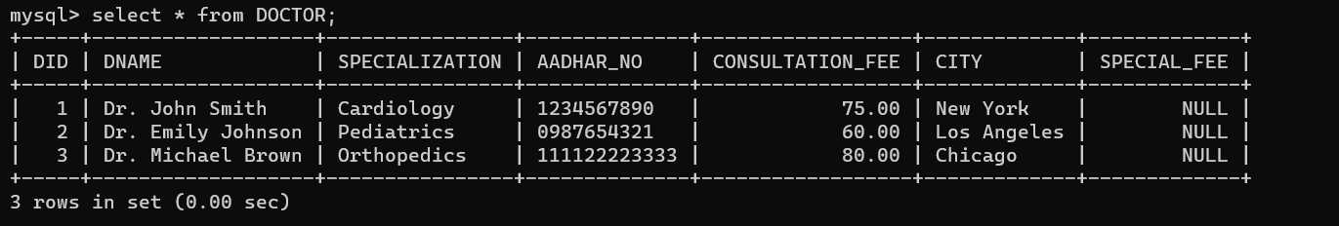

c) Add a check constraint to show that SPECIAL_FEE > CONSULTATION_FEE

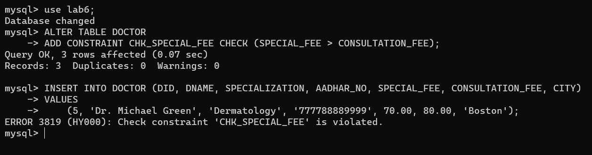

1. Using alter command, Drop the constraint C1.

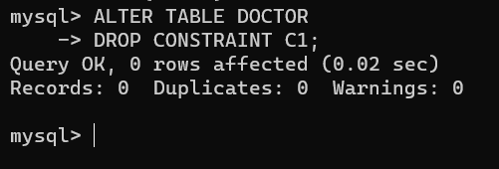

e) Add a column AADHAR_NUMBER to patient table with UNIQUE constraint

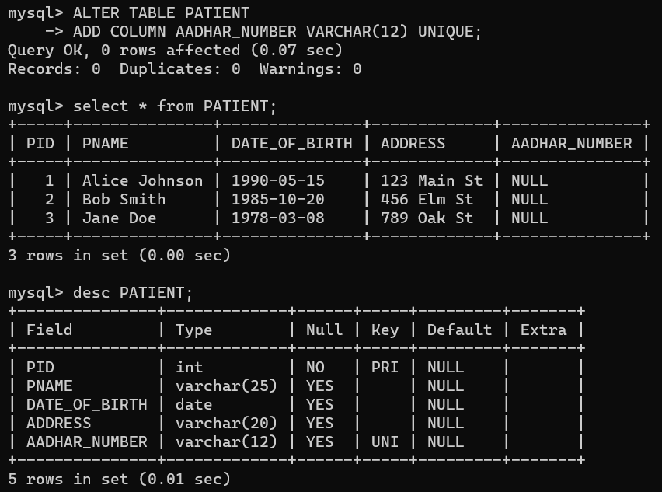

f) Add NOT NULL constraint to the DATE_OF_BIRTH column of PATIENT table.

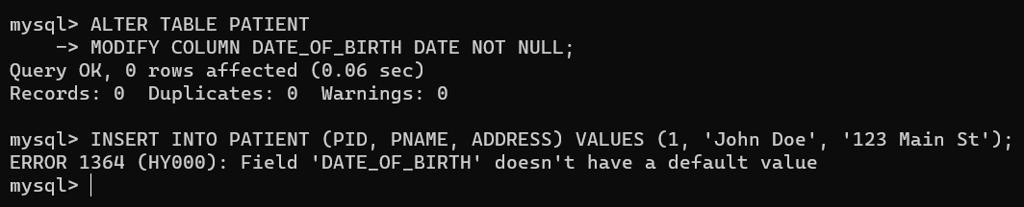

g) Delete a doctor from DOCTOR table

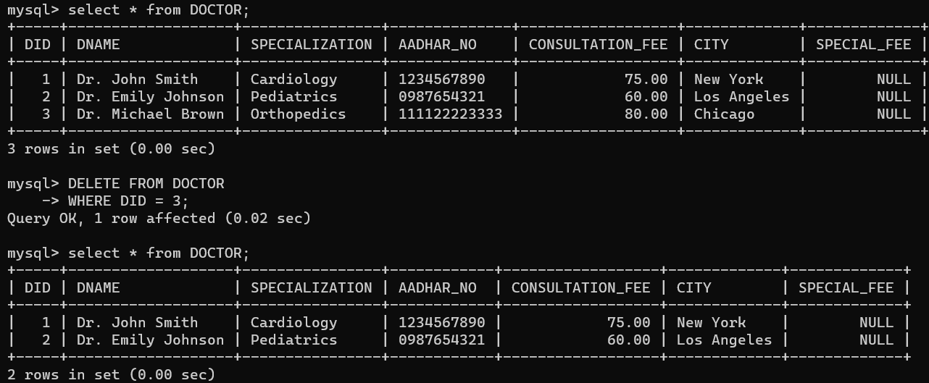

h) Display the name of the doctors whose consultation fees are even.

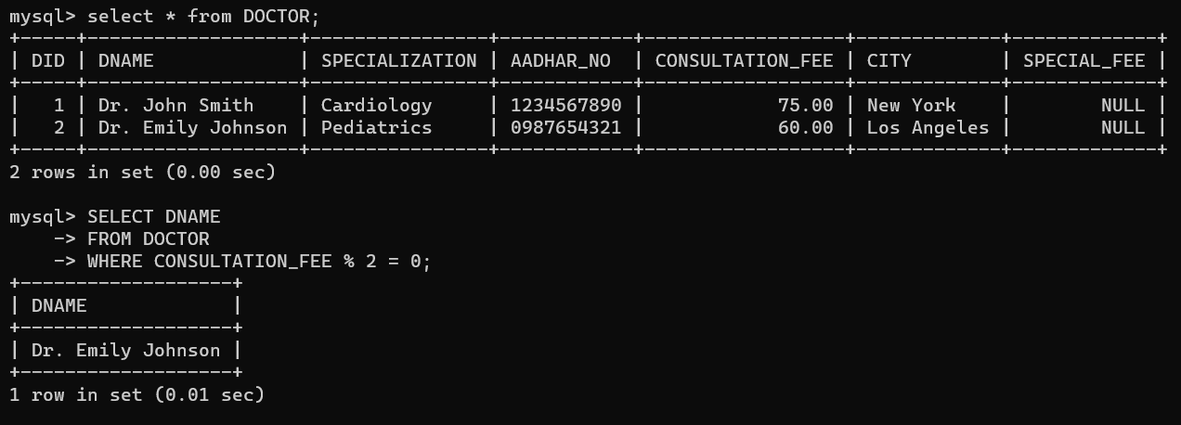

i) Find the doctors whose name starts with ‘K’ and ends with ‘n’

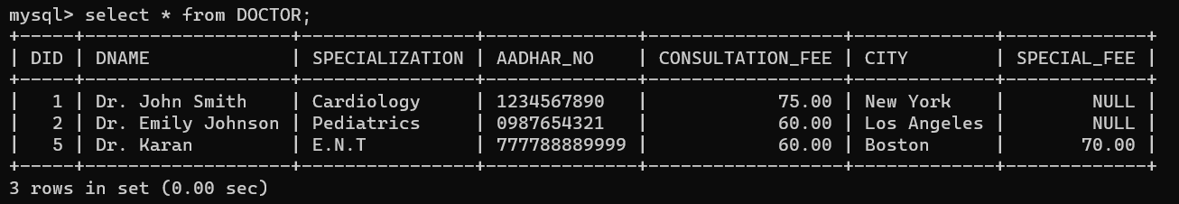

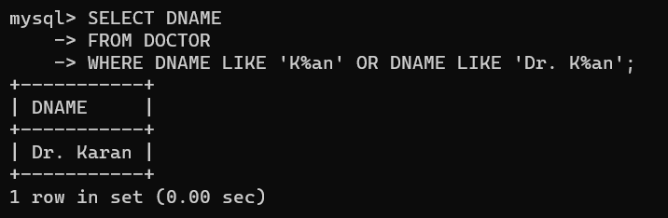

j) Find the patients whose name starts with ‘A’ and is followed by 2 characters only.

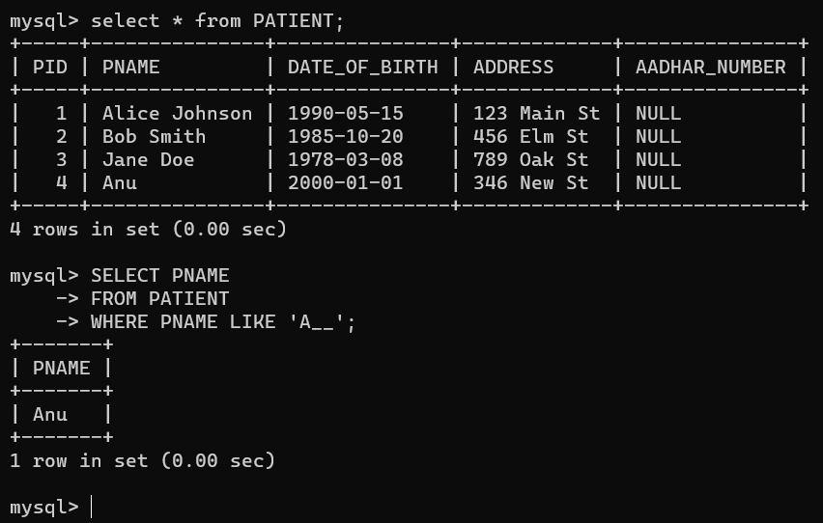

k) Find the doctors whose name starts with ‘J’ or ‘L’

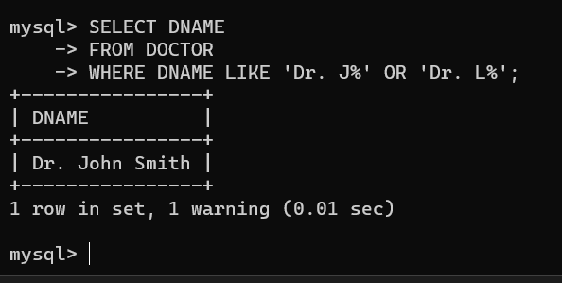

l) Find the doctors whose specialization is ‘E.N.T’ and consultation fee is more than 60

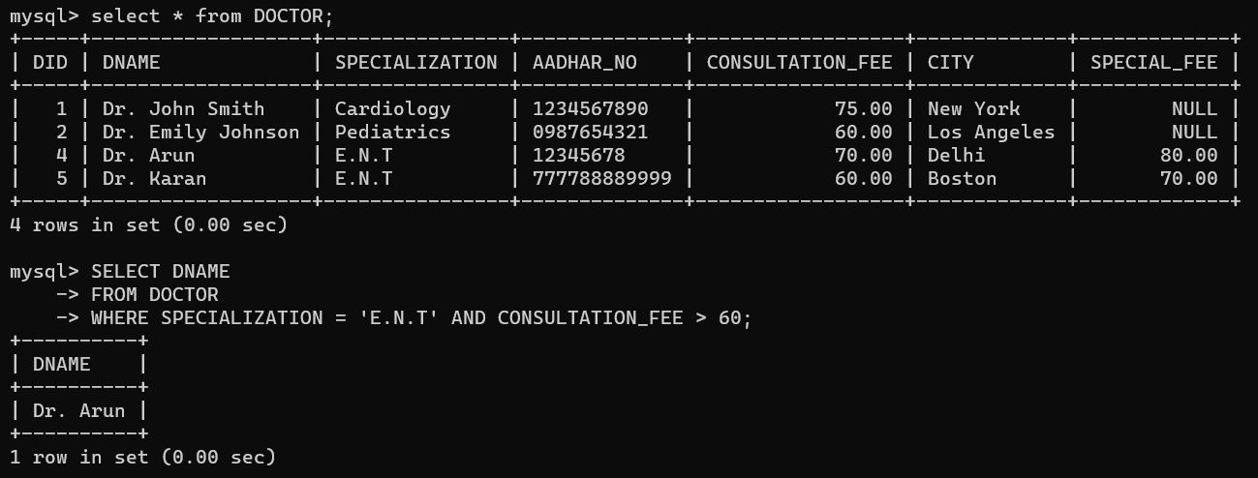

m) Find the doctors whose consultation fee is between 50 and 100

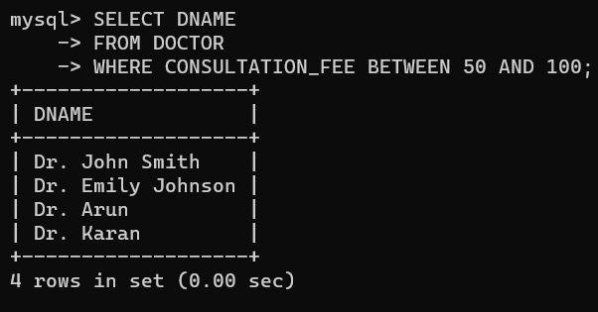

n) Arrange the doctors in the descending order of name as well as city

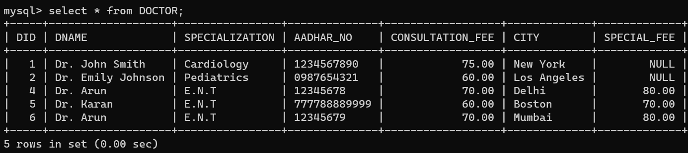

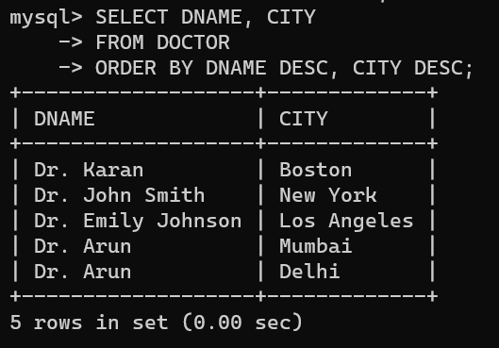

o) List the specialization of doctors without duplicate values.

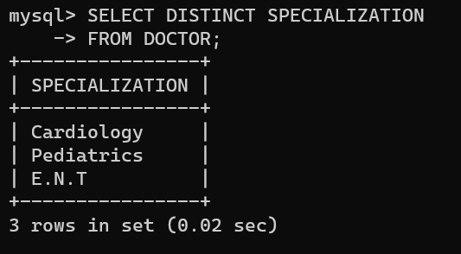

p) Find the total number of doctors

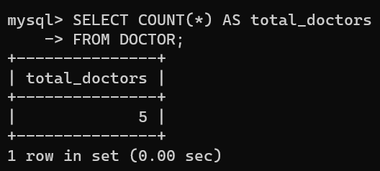

q) Find the number of doctors with ‘E.N.T’ specialization.

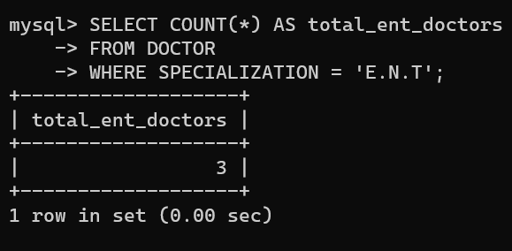

r) Find the number of patients who were treated by a doctor with ID = 1;

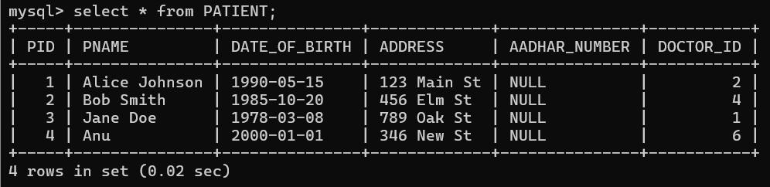

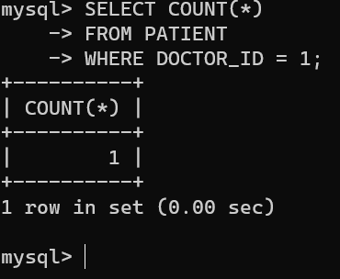

s) Display the total fee i.e. special fee + consultation fee, for each doctor. (Use heading ‘TOTAL_FEE’

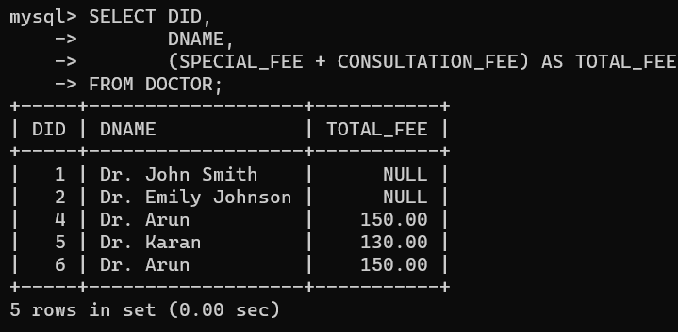

t) Find the number of doctors with no adhar number given. (i.e. is null)

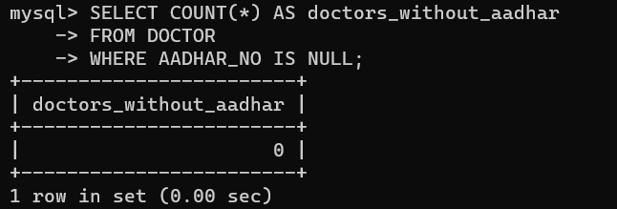

u) Find the number of doctors with adhar number given. (i.e. is not null)

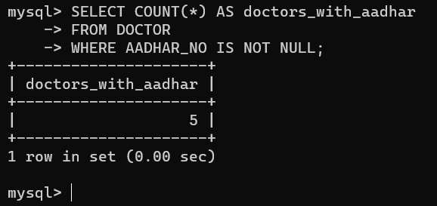

v) Find the doctors whose CONSULTATION FEE is greater than 100 and SPECIALIZATION is Cardiac or coming from Kollam.

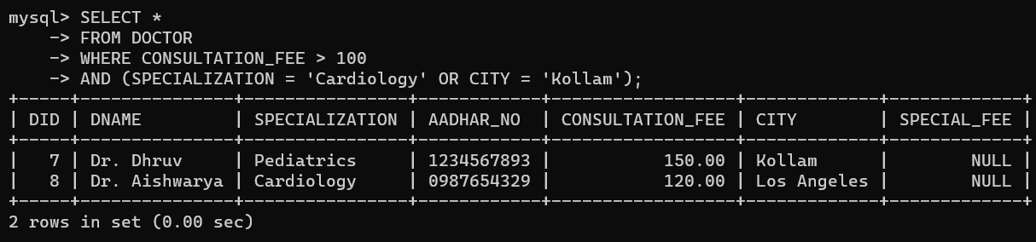

w) Find the result of the query: select * from doctor order by 3

